**DAILY ONLINE ACTIVITIES SUMMARY**

|  |  |  |  |  |  |  |  |  |
| --- | --- | --- | --- | --- | --- | --- | --- | --- |
| **Date:** | **13/6/2020** | | | | | **Name:** | **Apoorva u** | |
| **Sem & Sec** | **8th Sem** | | | | | **USN:** | **4AL16CS017** | |
| **Online Test Summary** | | | | | | | | |
| **Subject** | | **IOT** | | | | | | |
| **Max. Marks** | | **30** | | **Score** | | | **28** | |
| **Certification Course Summary** | | | | | | | | |
| **Course** | **Introduction to SQL** | | | | | | | |
| **Certificate Provider** | | | **datacamp** | | **Duration** | | | **4hrs** |
| **Coding Challenges** | | | | | | | | |
| **Problem Statement:**  Program to calculate Electricity Bill | | | | | | | | |
| **Status:COMPLETED** | | | | | | | | |
| **Uploaded the report in Github** | | | | | **yes** | | | |
| **If yes Repository name** | | | | | **Apoorva_u** | | | |
| **Uploaded the report in slack** | | | | | **yes** | | | |

Online Test Details: (Attach the snapshot and briefly write the report for the same)

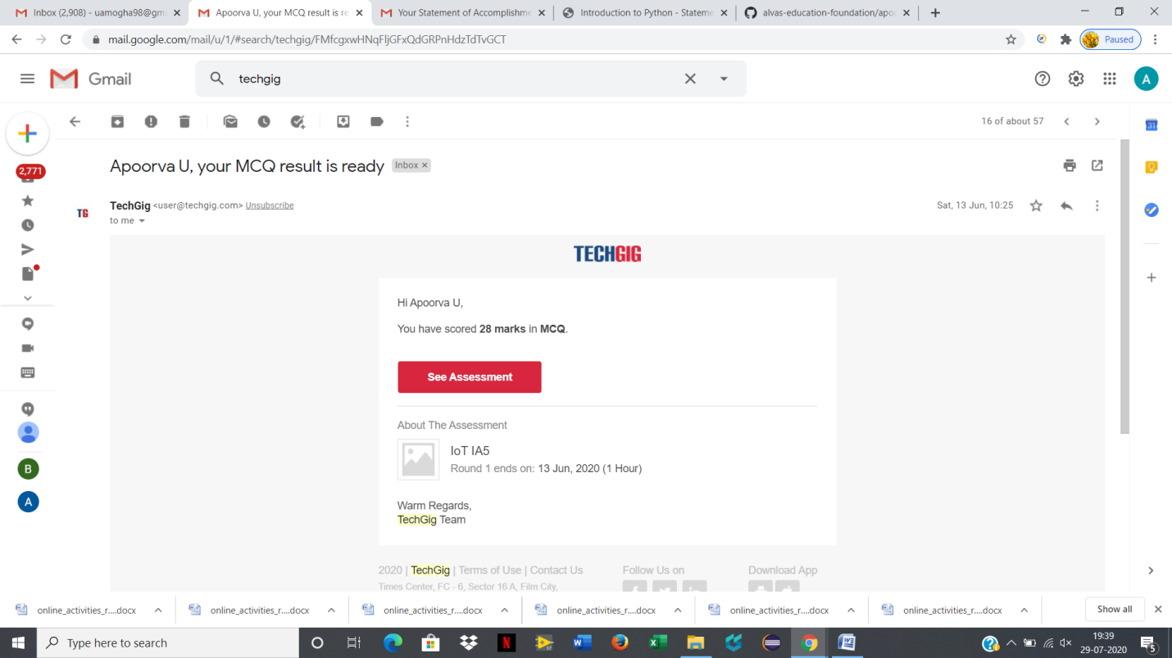

Certification Course Details: (Attach the snapshot and briefly write the report for the same)

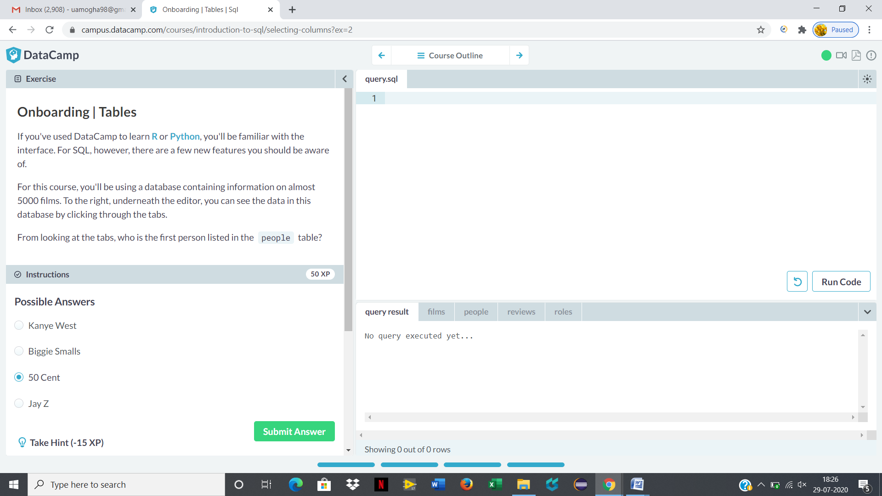

Coding Challenges Details: (Attach the snapshot and briefly write the report for the same)

**Program 1:**  
Program to calculate Electricity Bill

unit=int(input("Enter the unit consumed:")

def Bil_Calc(unit): #function definition

if(unit<=100): #below100units

print(unit*10);

elif(unit<=200): #below 200 units

print((100*10)+(unit-100)*15);

elif(unit<=300):#below300units

print(100*10)+(200-100)*15)+(unit-200)*20);

else: # above 300 units

print(100*10)+(200-100)*15)+(300-200)*20)+(unit-300)*25);

Bil_Calc(unit) #function cal